

Sagol School of Neuroscience
Department of Neuroscience and Brain Disorders
Gray Faculty of Medical and Health Sciences

Infra-slow fluctuations of sigma power in NREM2 sleep are altered by aging but not further by mild cognitive impairment (MCI)

By

Shaked Aglamaz

The thesis was carried out under the supervision of

Professor Yuval Nir
July, 2023
Acknowledgements
I would like to thank …
e.g.
Noa Bregman for professional support at the Tel Aviv Sourasky Medical Center, and for referring patients to the study; Rivi Tauman and Jenny Zitser for guidance with sleep medicine and PSG monitoring Rotem Falach, Flavio Schmidig, … … for

Table of Contents #here’s an example from different thesis, adapt to yours#

Abstract 6
Introduction 8
Sleep 8
Sleep, Learning and Memory 9
Sleep and Aging 10
Sleep and Neurodegeneration 11
Alzheimer’s Disease (AD) 11
Sleep in Alzheimer’s Disease 13
Mild Cognitive Impairment (MCI) 14
Amnestic Mild Cognitive Impairment 14
Sleep in MCI 15
Methods 17
Participants 17
Procedure 20
Cognitive testing 20
The memory paradigm 20
EEG data acquisition 21
Sleep Scoring 22
Memory Performance 24
Statistical Analysis 24
Results 25
Memory Performance 25
Sleep Architecture 27
Discussion 31
General sleep anatomy data framework 32
T
Implications 36
Future research 37
Supplementary 39
References 42

Abstract
During non-rapid eye movement (NREM) sleep stage 2 (N2), the occurrence of sleep spindles in the sigma (13–16 Hz) band fluctuates following an infra-slow timescale of roughly 0.02 Hz (oscillation with period of ~50 sec). This infra-slow fluctuation of sigma power (ISFS) is associated with changes in the locus-coeruleus noradrenergic (LC-NE) activity and other arousal systems and with related autonomic measures. In humans, the ISFS has been characterized in young adults. Here, we set out to investigate whether ISFS changes with aging and mild cognitive impairment (MCI). To this end, we performed full night polysomnography (PSG) including high-density (256-channel) EEG in 35 young adults (mean age = 27), 39 healthy older adults (mean age = 66), and 30 patients with amnestic MCI referred from a cognitive neurology clinic (mean age = 67). We characterized the ISFS during N2 sleep by applying an established analysis pipeline to EEG data, and quantifying the peak frequency, bandwidth, and area under the spectral peak (AUC) of the sigma-envelope spectrum at every scalp EEG channel. We found that older age was associated with significantly higher peak frequency (p = 0.0026) and with a trend towards broader bandwidth (p = 0.061). Overall AUC across all scalp channels was preserved, but the central-parietal ISFS hotspot, prominent in young adults, was significantly less focal (smeared) in older age (cluster p = 0.023). We could not reveal significant differences in ISFS parameters between individuals with aMCI and healthy older adults, or correlations between ISFS parameters and cognitive status. Thus, the ISFS is reshaped by aging, becoming faster and losing its central-parietal focus, rather than by mild cognitive impairment.

Introduction
Human sleep and scalp EEG
Put one more general paragraph to begin with – for thesis (unnecessary for paper) on stuff like
- Sleep what is it, how is it defined, sleep stages NREM and REM
- What are the function(s) of sleep what is it good for
- PSG monitoring, EEG signatures e.g. slow waves, sleep spindles etc

Infra-slow fluctuation of sigma power (ISFS) in NREM sleep
Non-rapid eye movement (NREM) sleep occupies most of sleep in adults, and stage 2 (N2) is characterized by the intermittent occurrence of sleep spindles: brief oscillations in the sigma band (11–16 Hz) generated by thalamocortical circuits¹⁻². Spindles are among the most reliable electrophysiological signatures of N2 and vary in density and topography across individuals³. Two subtypes are commonly distinguished by frequency and scalp topography: slow spindles (≈11–13 Hz), maximal over frontal cortex, and fast spindles (≈13–16 Hz), maximal over centroparietal cortex⁴. Spindles are also closely tied to plasticity and sleep-dependent memory consolidation¹, as well as with increased disconnection from the external sensory environment.
Spindles are not distributed evenly through NREM sleep. The amplitude of sigma-band activity over time forms the sigma envelope, and this envelope fluctuates on an infra-slow timescale of roughly 0.02 Hz, so that spindles occur in trains separated by intervals of tens of seconds⁵. In both rodents and humans, this infra-slow fluctuation of sigma power (ISFS) organizes NREM sleep into alternating fragile and offline substates: during fragile periods sigma power is low and the animal is readily aroused, whereas during offline periods sigma power is high and the animal is relatively disconnected from sensory input and protected from awakening. This alternation is driven in part by the locus coeruleus norepinephrine (LC-NE) system⁶⁻⁷. The amplitude of infra-slow noradrenergic oscillations is coupled to spindle dynamics and to the restorative and mnemonic functions of sleep⁸⁻⁹.
In the human EEG, the ISFS appears during N2 as a modulation of the sigma amplitude envelope at approximately 0.02 Hz. Such modulations are most prominent in fast spindles and over centro-parieto-occipital regions¹⁰. Dimitriades et al. (2024) characterized the ISFS across development and in young adults, quantifying the peak frequency, spectral width, and area under the spectral peak of the sigma envelope for each EEG channel, and linking these to markers of arousal and memory reactivation¹¹. The same infra-slow grouping of spindles tracks memory consolidation in humans¹².
Changes in sleep and EEG across aging and MCI
Put one more general paragraph on how sleep and EEG change with age and MCI stuff like
- Sleep, Learning and Memory
- Sleep and Aging
- Sleep and Neurodegeneration
- Alzheimer’s Disease (AD)
- Sleep in Alzheimer’s Disease
- Mild Cognitive Impairment (MCI)
- Amnestic Mild Cognitive Impairment
- Sleep in MCI what is known

Changes in sleep spindles and ISFS across aging and MCI

Healthy aging reshapes NREM sleep and its spindles. Spindle density falls, slow-wave–spindle coupling loosens, and the temporal clustering of spindles breaks down, changes that themselves track cognitive decline¹²⁻¹⁵. In mild cognitive impairment (MCI) and Alzheimer's disease, polysomnographic studies report further sleep disruption and, in particular, reduced parietal fast-spindle density¹⁶⁻¹⁷. Because these N2 changes emerge early and carry prognostic information, sleep-EEG features have been proposed as candidate markers of incipient cognitive impairment¹⁸⁻¹⁹.
Yet the ISFS itself has been characterized almost exclusively in young adults; whether and how it changes with healthy aging, and whether MCI adds a signal beyond that of aging, remain unknown. Here we quantified the ISFS during N2 sleep in three groups (young controls, healthy older adults, and patients with aMCI), applying the analysis pipeline of Dimitriades et al. (2024) to high-density 256-channel EEG. For each participant we measured the peak frequency, bandwidth, and AUC of the fast-spindle (13–16 Hz) sigma-envelope spectrum at every scalp channel, and compared the groups across the whole scalp, topographically, and within a pre-defined central-parietal region of interest. We asked whether these ISFS parameters and their scalp topography differ with age, and whether MCI departs from healthy aging or instead mirrors it.

Methods

3.1 Participants
Data were pooled from two centers both employing identical setups of high-density EEG sleep studies: one at the Tel Aviv Sourasky Medical Center (TASMC), Tel Aviv, Israel, and one at the CIRUS Centre for Sleep and Chronobiology, Woolcock Institute of Medical Research, Macquarie University, Sydney, Australia.
Three groups were analyzed: young healthy controls (n = 35; 27.1 ± 4.3 years, range 21–39; 20 female, 15 male), healthy older adults (n = 39; 66.5 ± 9.7 years, range 49–82; 23 female, 16 male), and patients with mild cognitive impairment (MCI; n = 30; 67.8 ± 9.1 years, range 46–80; 20 female, 10 male).
The Tel Aviv participants were drawn from the same cohort detailed in our previous work²⁰; there, MCI patients had been referred for subjective cognitive complaints to general practitioners, neurologists, geriatricians, and psychiatrists at the TASMC clinic. Montreal Cognitive Assessment (MoCA) scores were obtained during their stay in the sleep laboratory and were available for all of the Tel Aviv participants in the two older groups, but not for the Sydney participants (older adults 27.2 ± 2.6, n = 30; MCI 21.5 ± 4.3, n = 14). Beyond the diagnostic group criteria, recordings were excluded on technical grounds: too many bad channels, too many artifactual epochs, or too few clean N2 bouts (fewer than three; see Section 3.3). The per-group exclusion counts are reported in Table 1, which also summarizes the group demographics.
## ! what about apnea and breathing disorders. You can’t do sleep research in elderly without addressing this ##

Variable | Young | Elderly | MCI
N | 35  (TASMC 35 + Sydney 0) | 39  (TASMC 30 + Sydney 9) | 30  (TASMC 14 + Sydney 16)
Age (years) | 27.1 ± 4.3 | 66.5 ± 9.7 | 67.8 ± 9.1
MoCA | N/A | 27.2 ± 2.6 (n=30) | 21.5 ± 4.3 (n=14)
Exclusions
Total excluded | 10 | 4 | 12
Clean N2 bouts < X% of data | 4 | 2 | 3
Bad channels > Y% of electrodes | 4 | 1 | 4
Bad epochs > Z% of sleep time | 1 | 1 | 2
Total sleep time < 210 min | 1 | 0 | 3
Table 1. Participant demographics by group. For each group the table reports sample size (with the split between the Tel Aviv [TASMC] and Sydney [Woolcock] recording sites), age, and cognitive screening score (Montreal Cognitive Assessment, MoCA, where available), with exclusion counts and reasons summarized below. Young n = 35 (age 27.1 ± 4.3), elderly n = 39 (age 66.5 ± 9.7; MoCA 27.2 ± 2.6, n = 30), MCI n = 30 (age 67.8 ± 9.1; MoCA 21.5 ± 4.3, n = 14). Values are mean ± standard deviation.

3.2 Polysomnographic recordings
High-density polysomnography (PSG) was recorded throughout the night using a 256-channel recording system (Electrical Geodesics, Inc. [EGI]). Sleep was scored in 30 s epochs according to American Academy of Sleep Medicine (AASM) guidelines, using the sleep module of the Visbrain Python package²¹ within the SleepEEGpy platform²². #what about Sydney scoring, same? # The ISFS analysis was restricted to N2 sleep following previous work #REF.
! you are mixing Methods and Results. First describe all Methods without results (inclusion/exclusion and participant summary table is OK but not actual results). Then move to results, figures/
An overview of the recorded sleep across the three groups, including whole-night hypnograms (time-course of sleep stage dynamics) superimposed with EEG spectrograms (time-frequency dynamics), the distribution of sleep stages, and N2 bout properties, is shown in Figure 1.

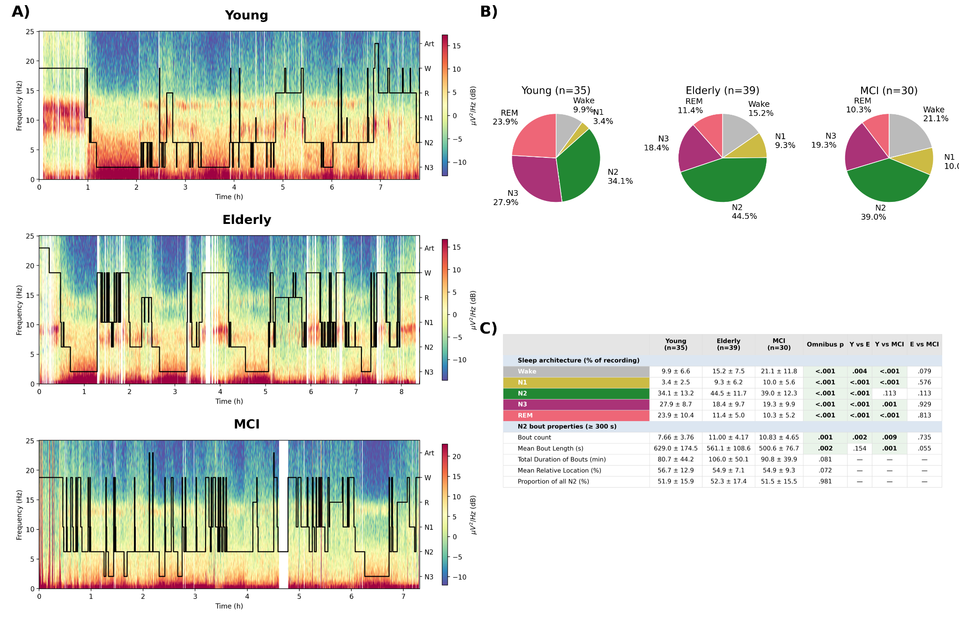
Figure 1. Sleep architecture across groups. A) Whole-night hypnogram and spectrogram for one representative subject per group. B) Proportion of each sleep stage per group: deep (N3) and REM sleep are reduced in elderly and MCI relative to young adults (both p < 0.001; per-stage statistics in panel C), whereas N2 sleep, the stage in which ISFS occurs, remains the largest stage in all three groups. C) Group comparison of sleep-stage proportions and N2 bout properties: elderly and MCI have more frequent but shorter N2 bouts than young adults, while the total proportion of N2 sampled is similar across groups.

Electrodes overlying the face, neck, and ears, which are not positioned over the scalp and are more prone to muscle and movement artifact, were excluded from analysis, leaving 176 channels for the analysis pipeline.
Recordings were resampled to 250 Hz, notch-filtered at 50 and 100 Hz with a zero-phase FIR filter to remove line noise and its first harmonic, and band-pass filtered between 0.1 and 40 Hz with a zero-phase FIR filter.
Bad channels and artifactual epochs were rejected with a semi-automatic procedure, in which each recording was inspected visually over its full duration. Across subjects, the proportion of channels rejected as bad was 6.3 ± 3.4% in young adults, 1.4 ± 1.8% in older adults, and 3.4 ± 4.4% in MCI patients, and the proportion of N2 time rejected as artifactual was 4.1 ± 4.9%, 3.3 ± 4.0%, and 1.8 ± 2.0%, respectively (mean ± SD). Data were then re-referenced to the common average reference, and channels rejected as bad were interpolated from neighboring channels.

3.3 N2 bout extraction
Clean N2 bouts were extracted by splitting each scored N2 period around any overlapping artifact annotation and retaining only segments of at least 300 s. #is this following zurich procedures? If yes then mention and cite# The 300 s minimum ensures that each bout contains at least two complete cycles of the lowest frequency of interest (0.0075 Hz, period ≈ 133 s). Each retained bout was analyzed independently. A minimum of three clean bouts per subject was required for inclusion; recordings yielding fewer were excluded as having insufficient artifact-free N2 for a stable ISFS estimate.

3.4 ISFS feature extraction
ISFS features were computed with a pipeline duplicated and extended from Dimitriades et al. (2024)¹¹, adapted here from their 128-channel montage to the 256-channel Electrical Geodesics, Inc. (EGI) system. The conceptual steps and a worked single-channel example are shown in Figure 2A–C.
For each channel, the fast-spindle sigma-band (13–16 Hz) amplitude envelope was obtained with a Gabor–Morlet wavelet transform, implemented as frequency-domain convolution via the Fast Fourier Transform (FFT). Wavelets spanned 13.0–16.0 Hz in 0.2 Hz steps with a fixed width of 4 cycles, and the resulting complex coefficients gave the time-varying sigma-power envelope.
For each clean N2 bout, the envelope was mean-subtracted to remove the DC component and Fourier-transformed; the squared-magnitude spectrum was interpolated onto a common frequency axis and normalized by its own mean. If the spectral maximum fell within the lowest frequency bins (0–0.006 Hz), those bins were discarded to suppress residual low-frequency drift. The normalized bout spectra were averaged within a channel, and a baseline estimated from 0.06–0.10 Hz, above the ISFS band, was subtracted to flatten the spectral floor.
A Gaussian, a·exp(−((f−b)/c)²), was fitted to the baseline-corrected mean spectrum by nonlinear least squares. A fit was accepted only if its peak amplitude exceeded the detection threshold (1.5 times the standard deviation of the spectrum), its peak frequency fell within the ISFS band 0.0075–0.04 Hz, and the numerically integrated area under the fitted peak was positive, which rejects degenerate fits. From each accepted fit we extracted three per-channel ISFS parameters: peak frequency (the frequency of the fitted maximum), bandwidth (the width of the b ± |c| band), and AUC (the integral of the fitted Gaussian over b ± |c|). Channels whose fit failed validation yielded no ISFS values and were treated as missing.

3.5 Region of interest
A central-parietal region of interest (ROI) was defined a priori from the young-adult AUC hotspot reported by Dimitriades et al. (2024)¹¹. Their 128-channel hotspot was mapped onto the 256-channel EGI layout by spatial correspondence, giving a fixed set of central-parietal electrodes (Figure 2D). The ROI was fixed before any group comparison, was identical for all subjects and groups, and was used specifically to compare the AUC parameter across the three groups (Section 3.6).
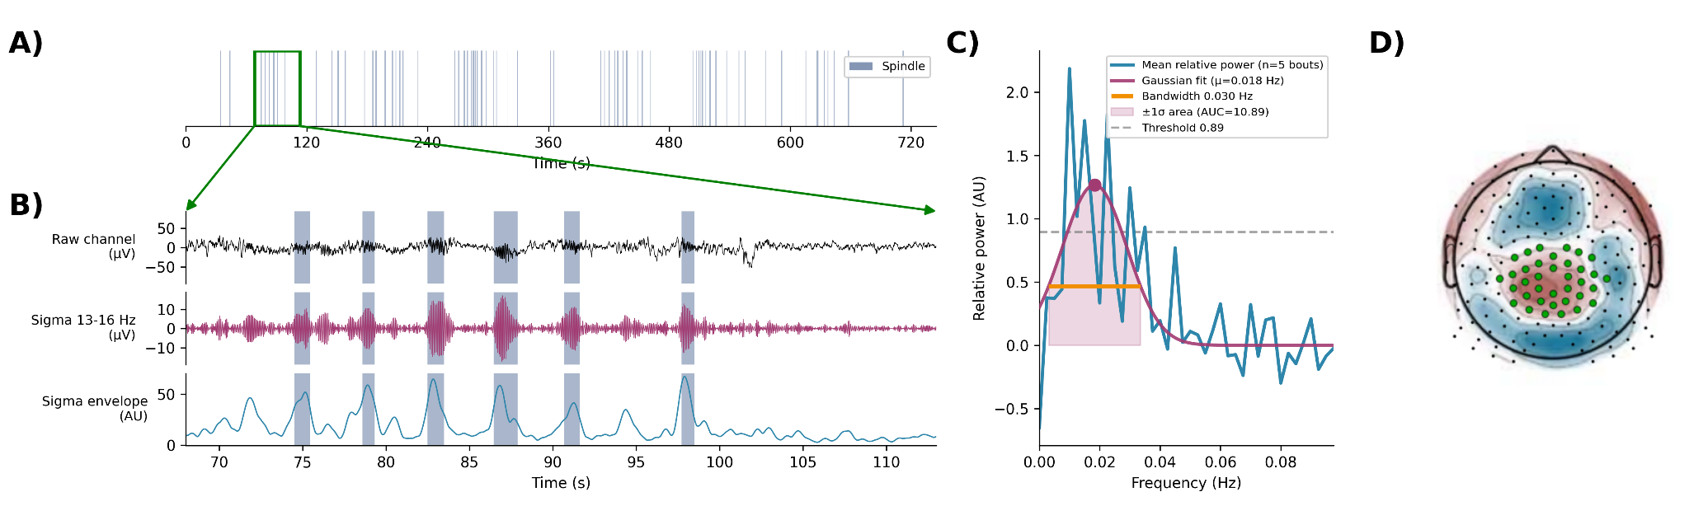
Figure 2. ISFS concept, feature extraction, and the central-parietal ROI. A) Spindle timeline for a representative recording: each bar marks a detected spindle. Spindles cluster on an infra-slow timescale of tens of seconds; this rhythmic clustering is the infra-slow fluctuation of sigma power (ISFS). The green box marks the window expanded in B). B) The expanded window (about 45 s) showing the raw EEG, the sigma power (13–16 Hz), and the sigma amplitude envelope. C) The fast Fourier transform (FFT) of the envelope, averaged across the subject's clean N2 bouts, fitted with a Gaussian that yields three metrics: peak frequency (the dominant rate of the rhythm), bandwidth (the spread of the peak), and area under the curve (AUC, the overall strength of the fluctuation). D) The pre-defined central-parietal region of interest (ROI): the electrodes (green) selected to represent the young-adult AUC hotspot of Dimitriades et al. (2024), mapped to the 256-channel EGI montage.

3.6 Statistical analysis
Group comparisons were performed at three levels: whole-scalp, topographic, and within the ROI.
Whole-scalp. For each ISFS parameter, each subject contributed a single value: the mean across all channels with an accepted fit. Per-group normality and variance homogeneity were checked with Shapiro–Wilk and Levene's tests. The three-group omnibus test was a one-way ANOVA when all groups were normal and a Kruskal–Wallis test otherwise, with effect size reported as η². When the omnibus was significant, post-hoc pairwise comparisons used Tukey's HSD (after ANOVA) or Dunn's test with Holm correction (after Kruskal–Wallis).
Topographic. Spatial group differences were tested with cluster-based permutation tests (MNE-Python²³). Channel adjacency was derived from the EGI 256-channel montage. The three-group analysis used an F-statistic with the cluster-forming threshold set at the p = 0.05 F-critical value (one-tailed), 5000 permutations. Tukey–Kramer post-hoc tests were run at each electrode of any significant cluster to localize the pairwise differences.
ROI and normalization. For the ROI analysis and for normalized topographies, each subject's per-channel values were first normalized by that subject's whole-scalp mean of the metric, and only then restricted to the ROI; normalizing within the ROI was deliberately avoided because it forces the ROI mean toward 1 by construction. The normalized AUC value per subject was the mean over the ROI channels, compared across groups with the same omnibus and post-hoc scheme as the whole-scalp analysis.
Throughout, the group mean displayed on a topography is the mean of the per-subject means, computed independently of the plotted image and matching the violin-plot statistic; missing channels in a topographic image were filled by spatial neighbor imputation for display only, never for the group statistics. Correlations between ISFS parameters and MoCA were assessed within the pooled older-adult and MCI sample.
Demographics and sleep architecture. Demographic variables were compared between the two older groups (age and MoCA) under the same normality-gated scheme: a Welch t-test when both groups passed Shapiro–Wilk and a Mann–Whitney U test otherwise. Group differences in sleep-stage proportions were tested with the same three-group omnibus and post-hoc scheme as the whole-scalp ISFS parameters.

3.7 Software
Analyses used Python with MNE-Python²³, NumPy, SciPy, pandas, and statsmodels. YASA²⁴ was used only to detect the spindles illustrated in Figure 2A and was not part of the ISFS analysis itself.

Results

4.1 Cohort and sleep architecture
The analysis included 35 young adults, 39 healthy older adults, and 30 patients with MCI. The two older groups were closely matched in age (elderly 66.5 ± 9.7 years, MCI 67.8 ± 9.1 years; Welch t = −0.56, p = 0.57) and both were older than the young group by design (27.1 ± 4.3 years). MoCA scores, available for subsets of the two older groups, were significantly lower in MCI than in the older controls (27.2 ± 2.6, n = 30 vs 21.5 ± 4.3, n = 14; Mann–Whitney U = 375.5, p < 0.001), consistent with the clinical group definition. Data quality was high in all three groups: on average fewer than 7% of channels were rejected as bad and interpolated, and fewer than 5% of N2 epochs were excluded as artifactual (Table 1).
Sleep architecture differed across groups (Figure 1). Time spent in N3 and in REM sleep were both reduced in the older and MCI groups relative to young adults (N3 one-way ANOVA p < 0.001; REM sleep p < 0.001), with the effect evident when comparing young versus each older group and no difference between elderly and MCI, consistent with normative age-related declines in slow-wave and REM sleep²⁵. Time spent in N2 sleep nonetheless remained the highest among all sleep stages across all three groups (~X % of total recording time), so the amount of N2 available for analysis was ample in every group and the group differences in ISFS reported below do not reflect differing amounts of N2 sleep.

4.2 ISFS detection and bout extraction
Clean N2 bouts of at least 300 s were extracted per subject and analyzed independently; 1023 bouts entered the analysis, a mean of 9.8 per subject (range 3–21).
The ISFS was detectable in the large majority of channels in every group of participants #. A valid Gaussian fit was obtained in a mean of 80.8% of the analyzed channels overall, and per group in 74.5% in young adults (range 20.5–100%), 85.6% in older adults (range 21.0–100%), and 82.0% in MCI (range 22.7–100%).

4.3 Whole-scalp ISFS parameters differ with age
For each subject the three ISFS parameters were summarized as the mean across all fitted electrodes and compared across groups (Figure 3).
First, we examined ISFS peak frequency across all scalp electrodes. ISFS peak frequency was around 0.02 Hz (range: #0.015-0.03Hz?) across all participants as expected. When comparing across groups, we found that peak frequency was higher in both older groups than in young adults (young 0.0199 ± 0.0041 Hz, elderly 0.0226 ± 0.0041 Hz, MCI 0.0232 ± 0.0040 Hz; one-way ANOVA F = 6.32, p = 0.0026, η² = 0.111). Post-hoc comparisons confirmed that young adults differed from both older groups (young vs elderly p = 0.013, young vs MCI p = 0.005), whereas the two older groups did not differ from each other (p = 0.86).
Next, we examined the bandwidth of the ISFS (i.e. the extent to which it was tightly or loosely locked around its peak frequency). Bandwidth also exhibited a trend towards higher values in elderly participants, but this did not reach statistical significance (young 0.0236 ± 0.0089 Hz, elderly 0.0281 ± 0.0085 Hz, MCI 0.0276 ± 0.0088 Hz; one-way ANOVA F = 2.87, p = 0.061, η² = 0.054).
We then quantified ISFS strength, measured as the area under the spectral peak (AUC). AUC did not differ significantly across groups at the whole-scalp level (young 6.46 ± 3.28, elderly 7.31 ± 2.88, MCI 7.48 ± 3.49; Kruskal–Wallis H = 1.96, p = 0.38).
The three examined ISFS parameters (peak frequency, bandwidth, and AUC) did not differ significantly between healthy elderly and aMCI groups.
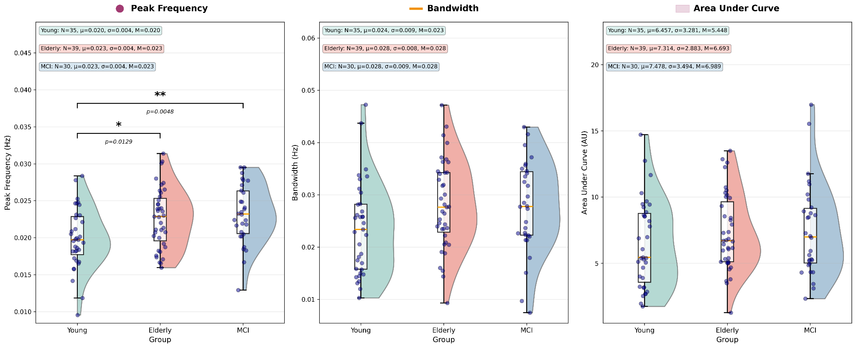
Figure 3. Whole-scalp ISFS parameters across groups. Each dot is one subject's mean across the fitted electrodes (young n = 35, elderly n = 39, MCI n = 30); the box shows the median and interquartile range, and the half-violin shows the kernel density. Peak frequency was higher in both older groups than in young adults (young < elderly = MCI; one-way ANOVA p = 0.0026, post-hoc young vs elderly p = 0.013, young vs MCI p = 0.005). Bandwidth trended in the same direction but did not reach significance (one-way ANOVA p = 0.061; no post-hoc tests). Overall strength (AUC) did not differ between groups (Kruskal–Wallis p = 0.38). Elderly and MCI did not differ on any parameter.

4.4 ISFS strength is focally reduced over central-parietal cortex
Next, we examined the ISFS topographical scalp distribution. Although whole-scalp AUC did not differ across groups when averaged across all electrodes, its scalp topography did (Figure 4). In young adults, AUC maps showed a central-parietal hotspot in accordance with previous studies #REF. By contrast, in the older and aMCI groups this hotspot was less focal and more diffuse (Figure 4A). A cluster-based permutation test on the per-subject normalized maps identified a single significant cluster over central-parietal electrodes (Figure 4B; p = 0.023, 9 electrodes: E130, E143, E144, E153, E154, E155, E184, E185, and E197). Post-hoc tests performed on these electrodes revealed lower AUC in the older and MCI groups than in young adults: the young-versus-elderly contrast was significant at 5 of the 9 electrodes and the young-versus-MCI contrast at 7, while the elderly-versus-MCI contrast was significant at only one (E197).
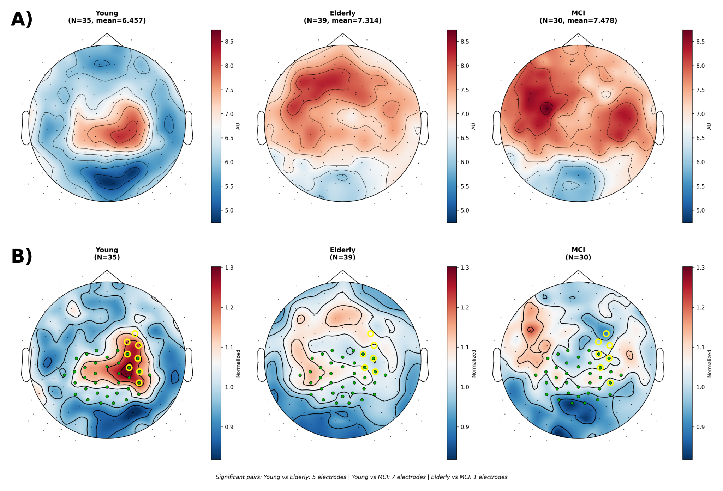
Figure 4. Topography of ISFS strength (AUC) and the central-parietal cluster. A) Raw (unnormalized) per-group AUC scalp maps. B) The corresponding per-subject normalized AUC scalp maps, with the cluster-based permutation result overlaid: the pre-defined central-parietal ROI is marked with green dots, and electrodes with a significant post-hoc group difference are circled in yellow. Young adults show higher AUC over the central-parietal electrodes, and the hotspot flattens and spreads in aging and MCI. A cluster-based permutation test identified a single significant central-parietal cluster (p = 0.023, 9 electrodes), driven by lower AUC in elderly and MCI than in young adults (post-hoc: young vs elderly significant at 5 of the 9 electrodes, young vs MCI at 7, elderly vs MCI at one).

4.5 ISFS strength within the central-parietal ROI
We complemented the data-driven analysis of ISFS scalp topography with an analysis within a predefined ROI. We sought to go beyond absolute AUC to characterize the proportion of overall AUC contained within this predefined ROI. To do so and quantify the central-parietal effect within the pre-defined region of interest, each subject's per-channel AUC was first normalized by that subject's whole-scalp mean and then averaged over the ROI electrodes (Figure 5). The results revealed a trend exhibiting the same order as the topographic result where ISFS strength over central-parietel electrodes was higher in young adults, lower in healthy elderly, and lowest in individuals with aMCI (young 1.099, elderly 1.040, MCI 1.012), but the three-group comparison was not significant (one-way ANOVA p = 0.143).
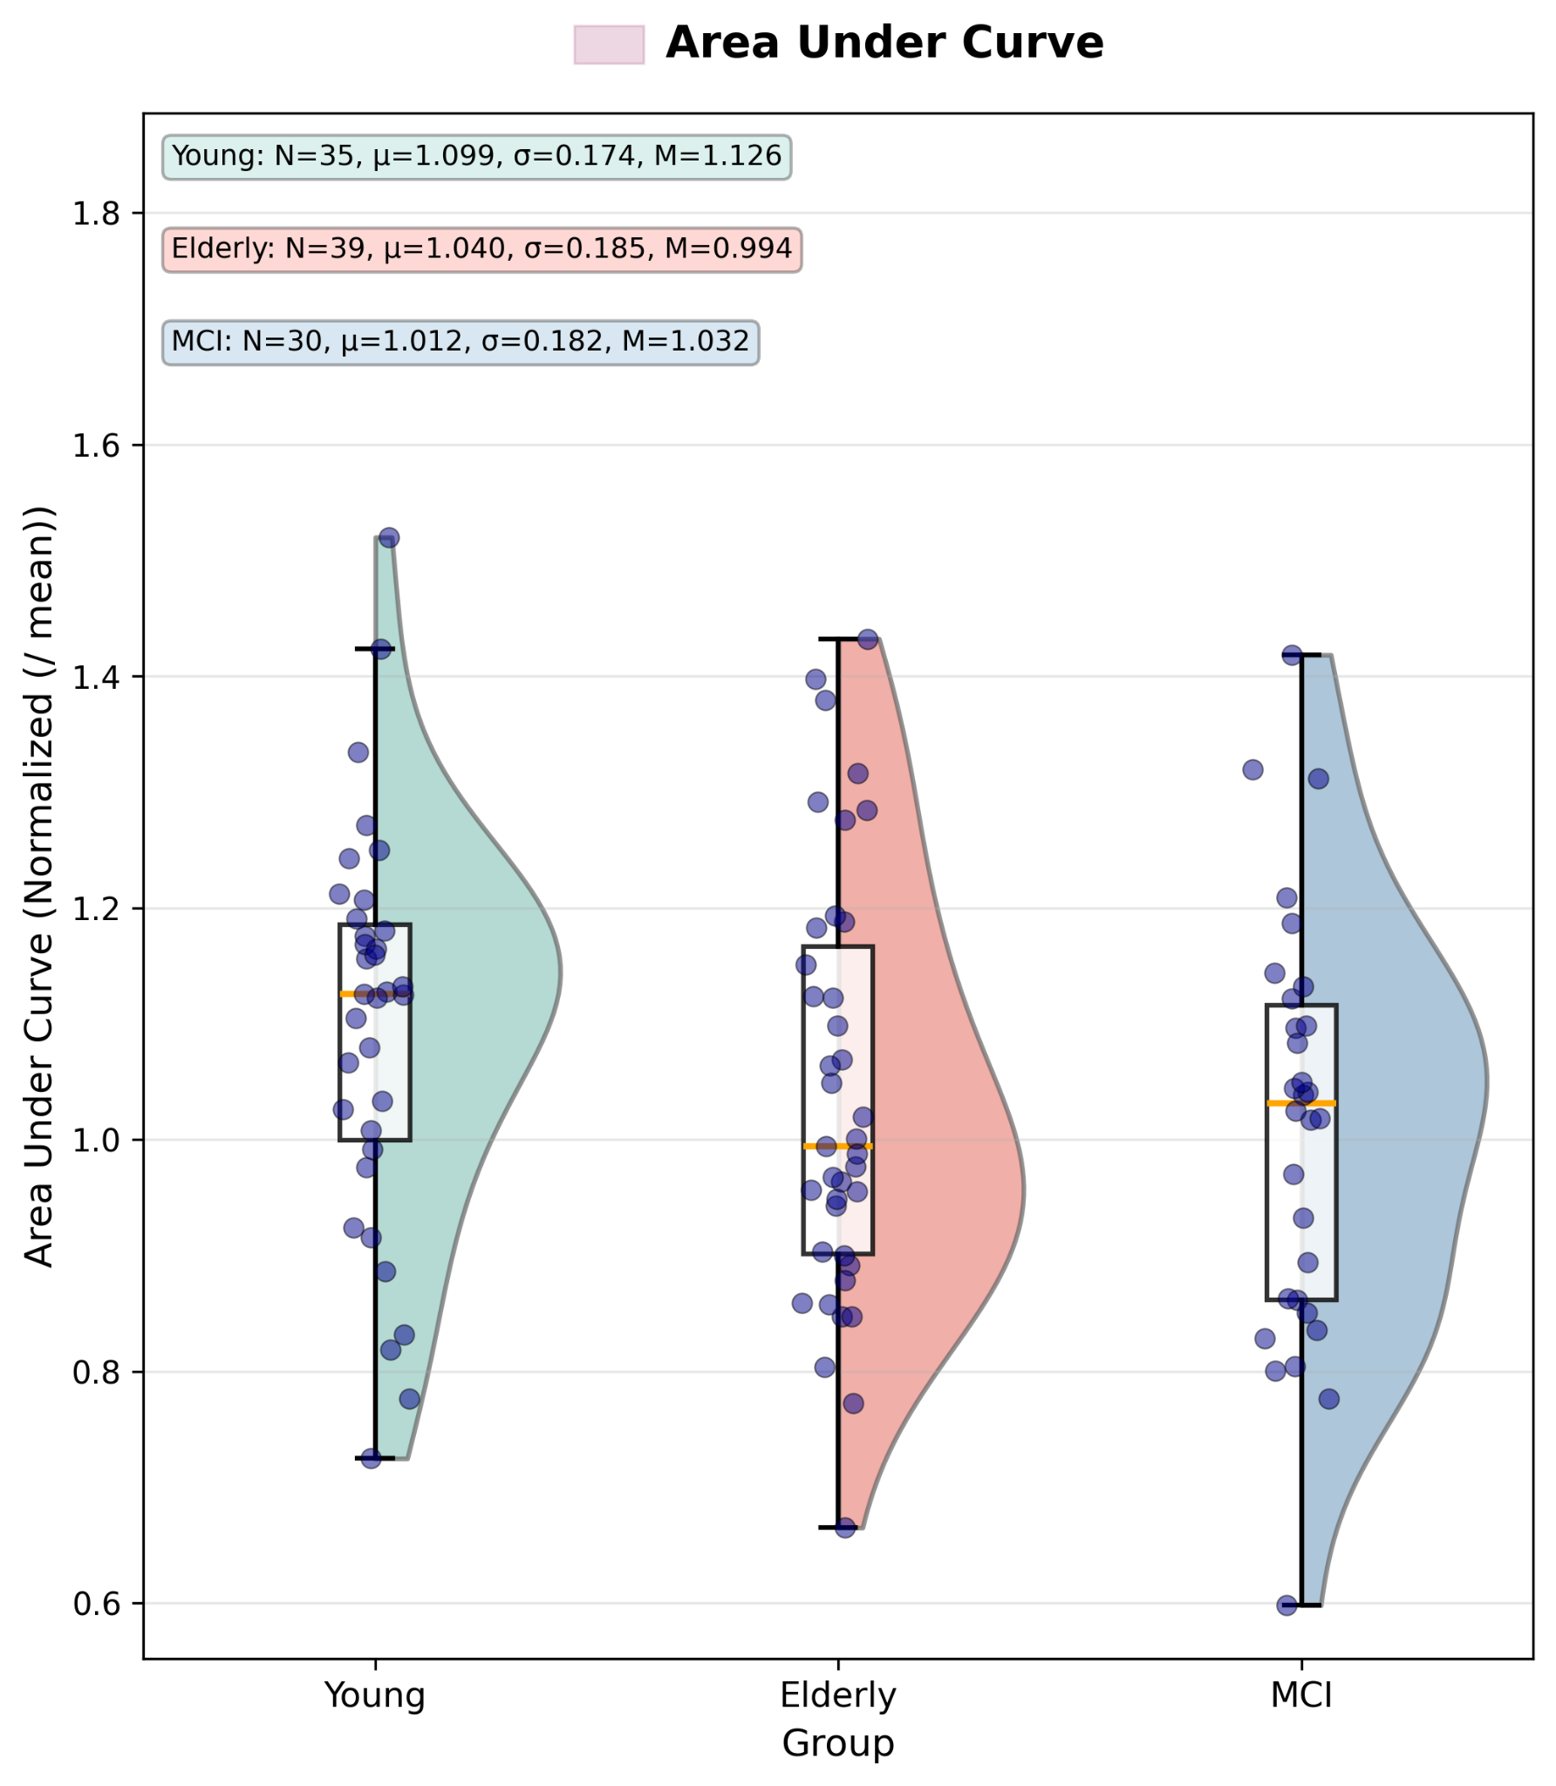
Figure 5. ISFS strength within the central-parietal ROI. Values are per-subject normalized. Each dot is one subject's mean across the fitted electrodes of the pre-defined central-parietal ROI. The group means followed the expected order (young 1.10, elderly 1.04, MCI 1.01), but the three-group comparison was not significant (one-way ANOVA, p = 0.143).

4.6 Peak-frequency and bandwidth topographies show no significant cluster
The same cluster-based permutation procedure was applied to the peak-frequency and bandwidth maps (Figure S1). In young adults, topographies resembled those reported previously #REF. When comparing the three groups, peak frequency showed a frontal emphasis in young adults that flattened in the older groups, and bandwidth showed no consistent spatial pattern, but neither parameter produced a significant spatial cluster.

4.7 No association with cognitive score
Within the pooled older-adult and MCI sample (n = 44), none of the ISFS metrics (peak frequency, bandwidth, whole-scalp AUC, or ROI AUC) correlated with MoCA score (all |r| ≤ 0.15, all p ≥ 0.34; Figure S2).

Discussion
Applying an established analysis pipeline to high-density EEG across three groups of young healthy adults, older healthy participants, and individuals with aMCI, we found that the ISFS during N2 sleep is reshaped by age along two axes. First, its peak frequency was higher in both older groups than in young adults (p = 0.0026). Second, its overall strength, although similar when averaged across the whole scalp, exhibited a focal hotspot over central-parietal cortex in young adults, but this focal hotspot “flattened” and became significantly more diffuse with age (cluster p = 0.023). A parallel tendency toward broader spectral width was present in the same direction but did not reach significance (p = 0.061); this effect was borderline and sensitive to which subjects were included, having reached significance in an earlier subject set, and is best read as a trend rather than an established effect. Individuals with aMCI were statistically indistinguishable from healthy older adults on every ISFS measure, and no ISFS parameter was associated with cognitive status as captured by MoCA scores. The dominant factor in our ISFS data is therefore age, rather than cognitive impairment.
Both observed changes are consistent with a loss of spatial and temporal precision in the thalamocortical mechanisms that organize fast spindles. In young adults, the ISFS is most pronounced in fast spindles and over centro-parieto-occipital cortex⁴,¹⁰, and the central-parietal hotspot recovered here reproduces the young-adult topography first described by Dimitriades and colleagues¹¹. The flattening of that hotspot together with an acceleration of the rhythm suggests that the roughly 0.02 Hz clock pacing spindle trains becomes both faster and less spatially concentrated, so that its energy is no longer focused where fast-spindle generators are densest. A similar loss of spatial structure was visible, though it did not reach significance, in the peak-frequency map: the frontal emphasis seen in young adults became more uniform across the scalp in the older groups, consistent with a general blurring of regional differentiation rather than a change confined to one parameter. A recent point-process analysis of spindle timing found that an infra-slow rhythm with a period of roughly 50 seconds contributes to, but does not dominate, the timing of spindles, with shorter-term refractory dynamics carrying much of the variance²⁶. A focal reduction in ISFS strength therefore need not translate proportionally into disorganized spindle output, and the AUC effect is more safely interpreted as a sensitive index of how the rhythm is distributed than as direct evidence of degraded spindle function.
The neuromodulatory systems that pace and generate spindles offer a plausible substrate for these age effects. The same rodent locus-coeruleus and noradrenergic machinery that clocks the infra-slow sigma rhythm⁶⁻⁷ is eroded by aging and early neurodegeneration. Cholinergic basal-forebrain projections degenerate along a defined cortical topography in early Alzheimer's disease²⁷, and REM-sleep EEG slowing has been shown to track cortical cholinergic denervation in aging and MCI²⁸, a parallel sleep-EEG signature of the same decline in a different sleep state. Against this background of waning neuromodulation, and the documented breakdown of fast-spindle timing with age¹⁵, a faster and spatially more diffuse ISFS points to a thalamocortical and neuromodulatory infrastructure whose temporal and spatial organization coarsens with age, a coarsening that in these data is already fully expressed in healthy older adults.
In our hands, aMCI contributed no detectable changes to ISFS properties beyond those observed with older age. While the MCI and elderly groups were closely matched in age and differed, as expected, in cognitive score, they were indistinguishable on peak frequency, bandwidth, whole-scalp strength, and the central-parietal cluster alike, and no ISFS measure correlated with the MoCA within the pooled older sample. This contrasts with a literature that has proposed N2 sleep-EEG features, and reduced parietal fast-spindle activity in particular, as candidate early markers of incipient cognitive impairment¹⁶⁻¹⁷. In the present cohort the ISFS behaves as a marker of chronological aging rather than of cognitive status, and the data temper, rather than support, the use of ISFS as a standalone biomarker of early MCI. One reading is that the changes captured here reflect neuromodulatory and thalamocortical aging that is already well advanced in healthy older adults and that the transition to MCI does not measurably accelerate, at least not at the resolution of these scalp-level summaries. On this view the ISFS tracks how far the brain has aged rather than whether cognition has begun to decline, and its insensitivity to MCI is itself informative about what the rhythm indexes.
These results can be read alongside a concurrent study by Grollero and colleagues, who measured the same collection of ISFS features in clinically diagnosed Alzheimer's disease²⁹. Recording home sleep EEG in ten patients with AD and twenty age-matched healthy controls, they extracted the peak frequency, amplitude, and bandwidth of the sigma-envelope spectrum and related them to plasma markers of AD pathology and to overnight memory. They found the amplitude of the rhythm selectively reduced in AD, with its frequency and bandwidth preserved; the amplitude reduction tracked the plasma amyloid ratio, and bandwidth tracked markers of neurodegeneration and poorer memory retention. Their amplitude result parallels our central-parietal AUC cluster, since both implicate a weakening of the rhythm's strength over central regions, although in our data this weakening accompanies healthy aging whereas in theirs it further separated AD from age-matched controls. The two studies also agree on frequency, which distinguished neither clinical contrast; the acceleration we observed is an effect of age that their older-only design could not capture. They diverge on whether cognitive impairment leaves a mark beyond age: the strength of the rhythm was reduced in their patients with established AD relative to age-matched controls, whereas our analogous strength measure did not separate MCI from healthy older adults, perhaps because MCI is an earlier disease stage. Together, these findings suggest that a disease-specific weakening of the rhythm may emerge later than the MCI stage, and that plasma and memory measures can detect associations a brief cognitive screen cannot. Because their study appeared after the present analysis was complete, the two are best read as independent and largely convergent evidence that the infra-slow sigma rhythm is sensitive to both aging and neurodegeneration.
Several limitations qualify these conclusions. The groups were of modest size and drawn from two recording sites, and the older and MCI cohorts were clinically and etiologically heterogeneous, which would obscure any subtle MCI-specific effect. Two of the parameters showed age-related tendencies that did not reach significance and should not be treated as robust. The bandwidth difference was not significant (p = 0.061) and, as noted, sensitive to which subjects were included, and the region-of-interest comparison likewise did not reach significance because averaging across the region dilutes a spatially focal effect that the cluster-based analysis captured directly; a larger cohort may yet resolve whether these sub-threshold effects are genuine. The design was cross-sectional, and therefore cannot distinguish individual aging trajectories or identify the subset of MCI patients who will progress; only a within-subject longitudinal design can do that. Cognitive scores were available for only part of the older sample, limiting the power of the brain–behavior analysis. Finally, the criterion we used to count a channel as showing a detectable rhythm was stricter than in earlier work, because we additionally rejected implausibly narrow spectral peaks that a looser criterion would have retained. The detection rates reported here are therefore conservative, and their lower values relative to prior reports reflect this stricter threshold rather than a real scarcity of the rhythm.
## I am missing (1) a paragraph putting these results in broader context of known changes in sleep between young, old, and MCI. It’s written as if “only the ISFS exists” floats in the air without reference to other things; what is know for example on sleep spindles irrespective of ISFS; what about other infraslow changes like cyclic alternating patten (CAP) – look it up; (2) a paragraph on what has been found on ISFS irrespective of aging/MCI; for example different medical conditions psychiatry neurology what is out there. Do people use same methods; do they report results in similar aspects (e.g. peak frequency, spatial spread) or different things; etc etc ##
Future work should test these effects longitudinally, following older and MCI participants over time to ask whether ISFS topography predicts conversion or tracks decline within individuals, where a cross-sectional comparison cannot. It would also be informative to examine how the ISFS couples to other infra-slow rhythms of sleep, including the slow oscillation and infra-slow hemodynamic fluctuations, and to pursue the rodent locus-coeruleus account translationally, given that the mechanistic origin of the human rhythm remains inferred rather than measured. The infra-slow sigma rhythm of N2 sleep is, on this evidence, a sensitive marker of how healthy aging reshapes the thalamocortical and spindle infrastructure of sleep, becoming faster and losing its central-parietal focus, but in this cohort it carried no signal specific to mild cognitive impairment. Beyond these findings, the study contributes a whole-scalp, topographic, and region-based characterization of the ISFS in aging and MCI that extends a measure previously described only in the young.

Supplementary figures

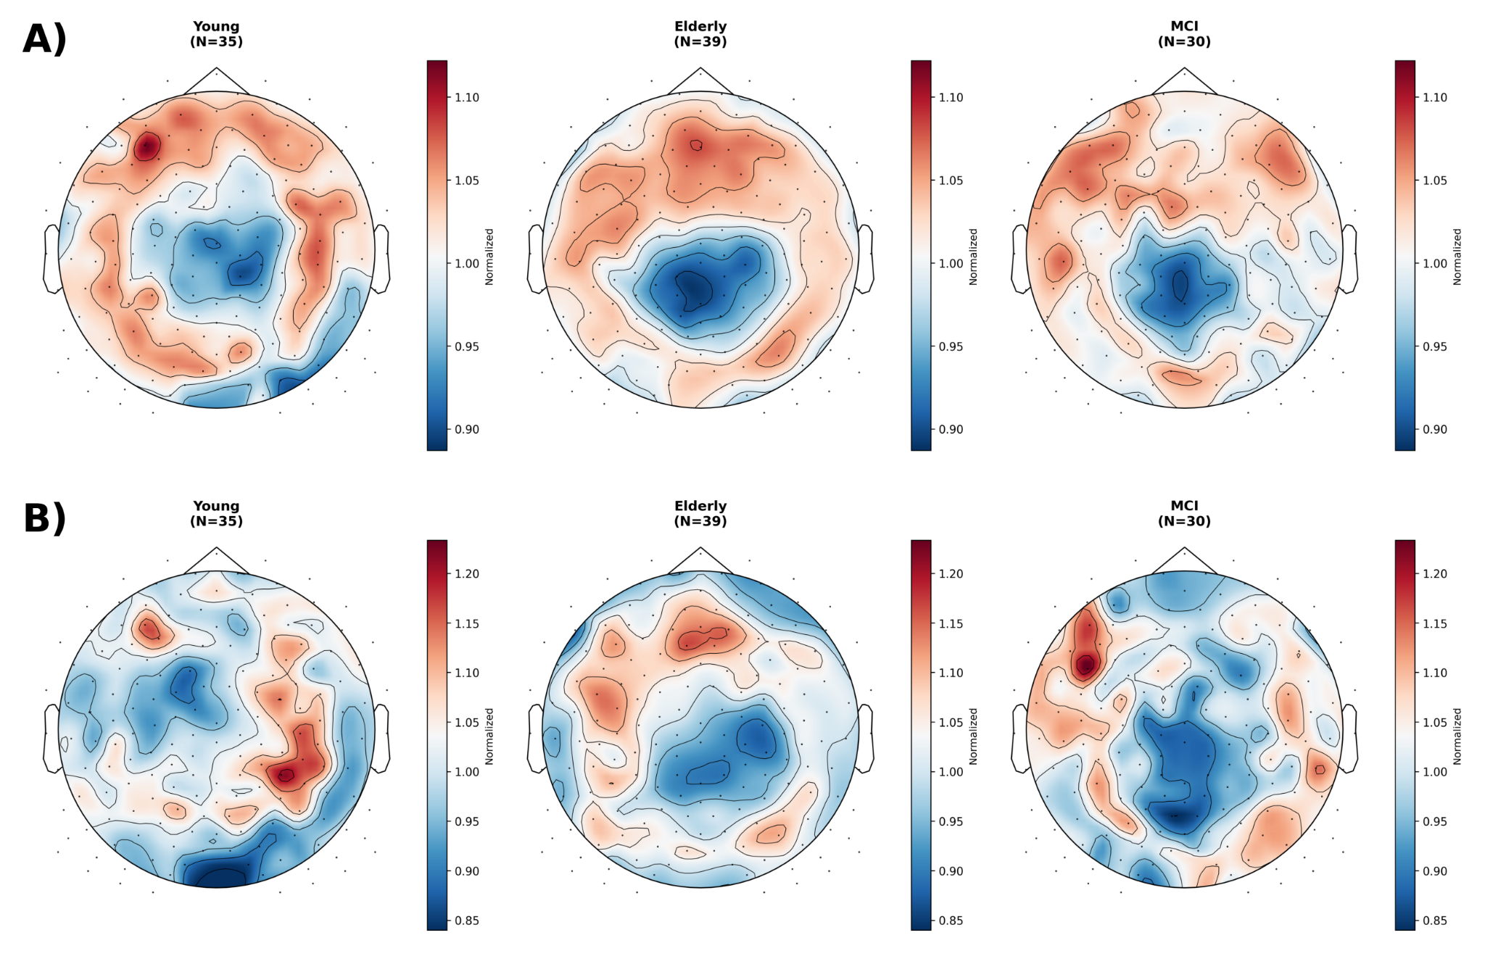
Figure S1. Peak-frequency and bandwidth topographies. Maps are per-subject normalized. A) Peak frequency shows a frontal emphasis in young adults that flattens with age. B) Bandwidth shows no consistent spatial pattern across groups. Neither parameter produced a significant spatial cluster.

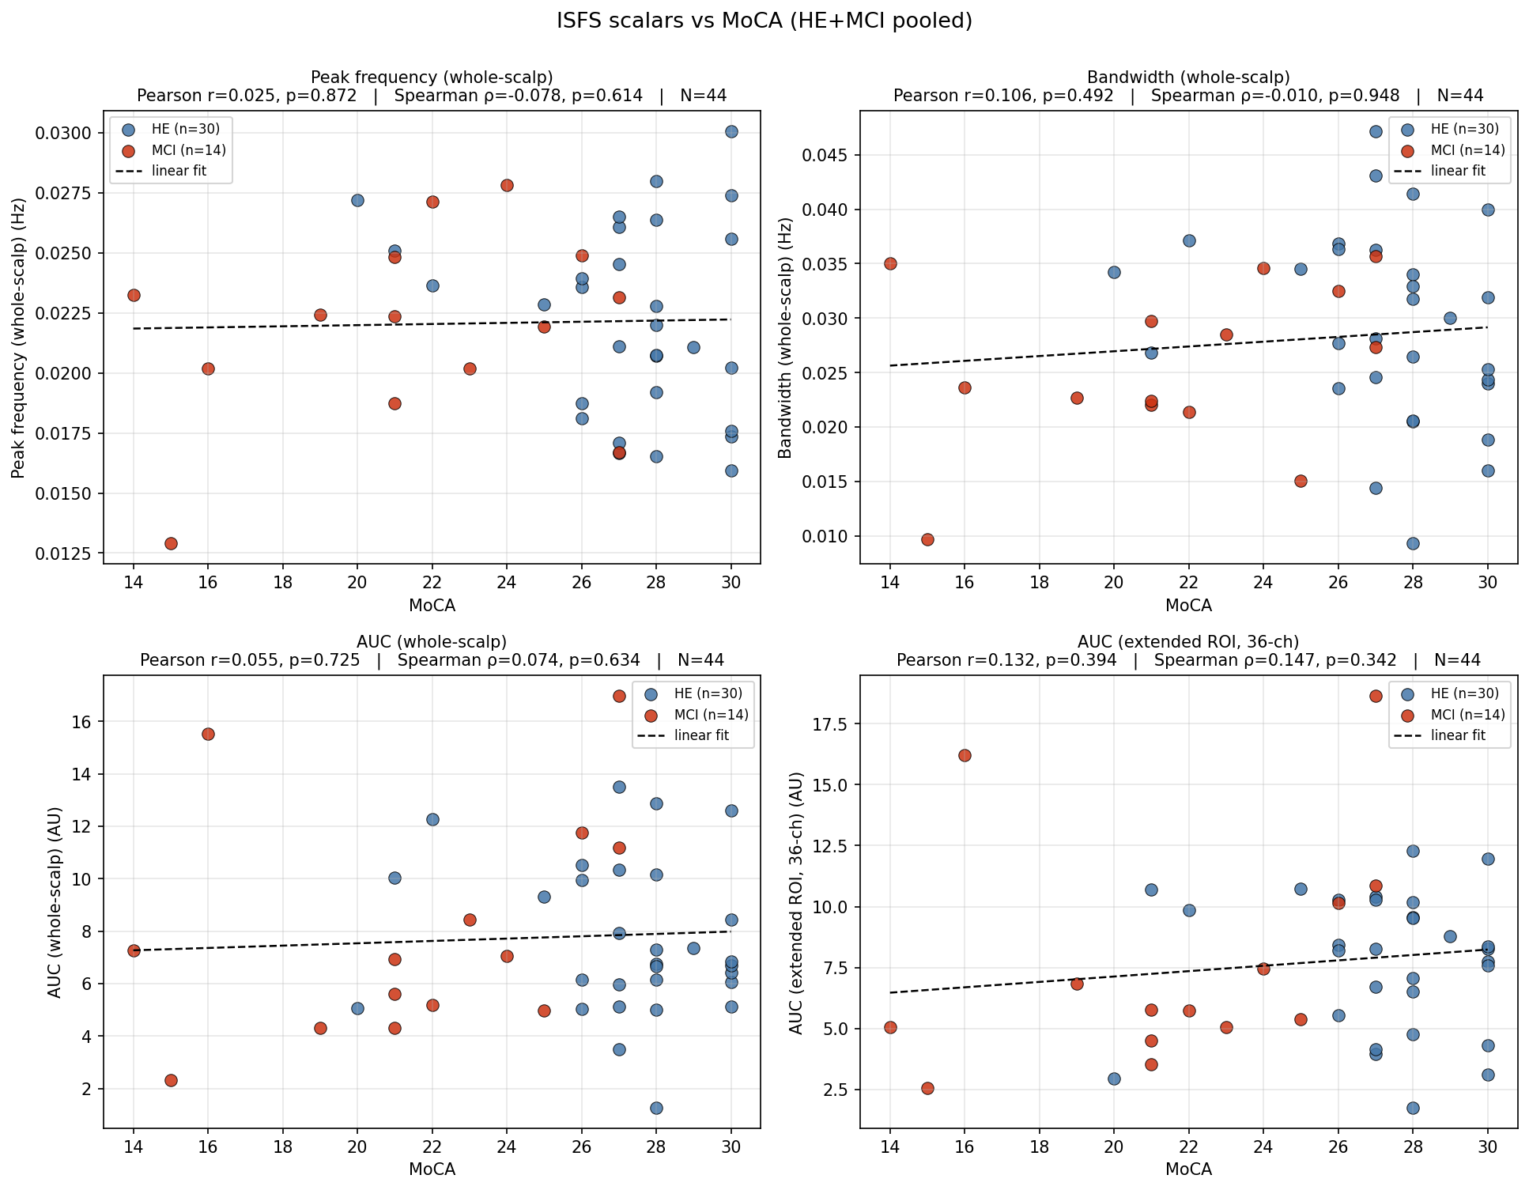
Figure S2. ISFS scalars versus MoCA. The sample is the pooled elderly and MCI group (n = 44). Each panel plots one scalar (peak frequency, bandwidth, whole-scalp AUC, or ROI AUC) against MoCA score. No scalar correlated with MoCA (all |r| ≤ 0.15, all p ≥ 0.34; Pearson and Spearman).

References
- Fernandez LMJ, Lüthi A. Sleep spindles: mechanisms and functions. Physiological Reviews. 2020;100(2):805–868. https://doi.org/10.1152/physrev.00042.2018
- Andrillon T, Nir Y, Staba RJ, Ferrarelli F, Cirelli C, Tononi G, et al. Sleep spindles in humans: insights from intracranial EEG and unit recordings. Journal of Neuroscience. 2011;31(49):17821–17834. https://doi.org/10.1523/JNEUROSCI.2604-11.2011
- Purcell SM, Manoach DS, Demanuele C, Cade BE, Mariani S, Cox R, et al. Characterizing sleep spindles in 11,630 individuals from the National Sleep Research Resource. Nature Communications. 2017;8:15930. https://doi.org/10.1038/ncomms15930
- Mölle M, Bergmann TO, Marshall L, Born J. Fast and Slow Spindles during the Sleep Slow Oscillation: Disparate Coalescence and Engagement in Memory Processing. SLEEP. 2011;34(10):1411–1421. https://doi.org/10.5665/SLEEP.1290
- Boutin A, Doyon J. A sleep spindle framework for motor memory consolidation. Philosophical Transactions of the Royal Society B: Biological Sciences. 2020;375(1799):20190232. https://doi.org/10.1098/rstb.2019.0232
- Lecci S, Fernandez LMJ, Weber FD, Cardis R, Chatton JY, Born J, et al. Coordinated infraslow neural and cardiac oscillations mark fragility and offline periods in mammalian sleep. Science Advances. 2017;3(2):e1602026. https://doi.org/10.1126/sciadv.1602026
- Osorio-Forero A, Cardis R, Vantomme G, Guillaume-Gentil A, Katsioudi G, Devenoges C, et al. Noradrenergic circuit control of non-REM sleep substates. Current Biology. 2021;31(22):5009–5023. https://doi.org/10.1016/j.cub.2021.09.041
- Kjaerby C, Andersen M, Hauglund N, Untiet V, Dall C, Sigurdsson B, et al. Memory-enhancing properties of sleep depend on the oscillatory amplitude of norepinephrine. Nature Neuroscience. 2022;25(8):1059–1070. https://doi.org/10.1038/s41593-022-01102-9
- Cardis R, Lecci S, Fernandez LMJ, Osorio-Forero A, Chu Sin Chung P, Fulda S, et al. Cortico-autonomic local arousals and heightened somatosensory arousability during NREMS of mice in neuropathic pain. eLife. 2021;10:e65835. https://doi.org/10.7554/eLife.65835
- Lázár ZI, Dijk DJ, Lázár AS. Infraslow oscillations in human sleep spindle activity. Journal of Neuroscience Methods. 2019;316:22–34. https://doi.org/10.1016/j.jneumeth.2018.12.002
- Dimitriades ME, Osorio-Forero A, Fattinger S, von Arx S, Kurth S, Pugin F, et al. The Infraslow Fluctuation of Sigma Power During Sleep: Links to Markers of Arousal and Memory Reactivation Across Development. bioRxiv [preprint]. 2024. https://doi.org/10.1101/2024.11.06.620875
- Champetier P, Bertran F, Rauchs G, André C, Weber FD, Rehel S, et al. Age-Related Changes in Fast Spindle Clustering During Non-Rapid Eye Movement Sleep and Their Relevance for Memory Consolidation. SLEEP. 2023;46(5):zsac282. https://doi.org/10.1093/sleep/zsac282
- Mander BA, Winer JR, Walker MP. Sleep and Human Aging. Neuron. 2017;94(1):19–36. https://doi.org/10.1016/j.neuron.2017.02.004
- Helfrich RF, Mander BA, Jagust WJ, Knight RT, Walker MP. Old Brains Come Uncoupled in Sleep: Slow Wave–Spindle Synchrony, Brain Atrophy, and Forgetting. Neuron. 2018;97(1):221–230. https://doi.org/10.1016/j.neuron.2017.11.020
- Niethard N. Aging Impairs the Temporal Clustering of Sleep Spindles. SLEEP. 2023;46(5):zsad011. https://doi.org/10.1093/sleep/zsad011
- Zhang Y, Ren R, Yang L, Zhang H, Shi Y, Okhravi HR, et al. Sleep in Alzheimer's Disease: A Systematic Review and Meta-Analysis of Polysomnographic Findings. Translational Psychiatry. 2022;12:136. https://doi.org/10.1038/s41398-022-01897-y
- Gorgoni M, Lauri G, Truglia I, Cordone S, Sarasso S, Scarpelli S, et al. Parietal Fast Sleep Spindle Density Decrease in Alzheimer's Disease and Amnesic Mild Cognitive Impairment. Neural Plasticity. 2016;2016:8376108. https://doi.org/10.1155/2016/8376108
- Taillard J, Sagaspe P, Berthomier C, Brandewinder M, Amieva H, Dartigues JF, et al. Non-REM Sleep Characteristics Predict Early Cognitive Impairment in an Aging Population. Frontiers in Neurology. 2019;10:197. https://doi.org/10.3389/fneur.2019.00197
- Liu S, Pan J, Tang K, Lei Q, He L, Meng Y, et al. Sleep spindles, K-complexes, limb movements and sleep stage proportions may be biomarkers for amnestic mild cognitive impairment and Alzheimer's disease. Sleep and Breathing. 2020;24(2):637–651. https://doi.org/10.1007/s11325-019-01970-9
- Sharon O, Zhelezniakov V, Gat Y, Falach R, Narbayev D, Shiner T, et al. Slow Wave Synchrony During NREM Sleep Tracks Cognitive Impairment in Prodromal Alzheimer's Disease. Alzheimer's & Dementia. 2025. https://doi.org/10.1002/alz.70247
- Combrisson E, Vallat R, O'Reilly C, Jas M, Pascarella A, Saive AL, et al. Visbrain: A Multi-Purpose GPU-Accelerated Open-Source Suite for Multimodal Brain Data Visualization. Frontiers in Neuroinformatics. 2019;13:14. https://doi.org/10.3389/fninf.2019.00014
- Falach R, Belonosov G, Schmidig FJ, Aderka M, Zhelezniakov V, Shani-Hershkovich R, et al. SleepEEGpy: a Python-based software integration package to organize preprocessing, analysis, and visualization of sleep EEG data. Computers in Biology and Medicine. 2025;192:110232. https://doi.org/10.1016/j.compbiomed.2025.110232
- Gramfort A, Luessi M, Larson E, Engemann DA, Strohmeier D, Brodbeck C, et al. MEG and EEG data analysis with MNE-Python. Frontiers in Neuroscience. 2013;7:267. https://doi.org/10.3389/fnins.2013.00267
- Vallat R, Walker MP. An open-source, high-performance tool for automated sleep staging. eLife. 2021;10:e70092. https://doi.org/10.7554/eLife.70092
- Ohayon MM, Carskadon MA, Guilleminault C, Vitiello MV. Meta-Analysis of Quantitative Sleep Parameters From Childhood to Old Age in Healthy Individuals: Developing Normative Sleep Values Across the Human Lifespan. Sleep. 2004;27(7):1255–1273. https://doi.org/10.1093/sleep/27.7.1255
- Chen S, He M, Brown RE, Eden UT, Prerau MJ. Individualized Temporal Patterns Drive Human Sleep Spindle Timing. Proceedings of the National Academy of Sciences. 2025;122(2):e2405276121. https://doi.org/10.1073/pnas.2405276121
- Schmitz TW, Mur M, Aghourian M, Bedard MA, Spreng RN. Longitudinal Alzheimer's Degeneration Reflects the Spatial Topography of Cholinergic Basal Forebrain Projections. Cell Reports. 2018;24(1):38–46. https://doi.org/10.1016/j.celrep.2018.06.001
- André C, Bédard MA, Daneault V, Wickens R, Soucy JP, Lorrain D, et al. REM Sleep EEG Slowing Reflects Brain Cholinergic Denervation in Aging and Mild Cognitive Impairment. medRxiv [preprint]. 2025. https://doi.org/10.1101/2025.04.28.25326545
- Grollero D, Gabb V, Blackman J, de Vivo L, Coulthard E, Bellesi M. Are Infraslow Oscillations the Missing Link Between Sleep and Alzheimer's? bioRxiv [preprint]. 2026. https://doi.org/10.64898/2026.04.09.717425

